WOKWI PROJECT

**LINK**: <https://wokwi.com/projects/347128058787922514>

**OUTPUT**:

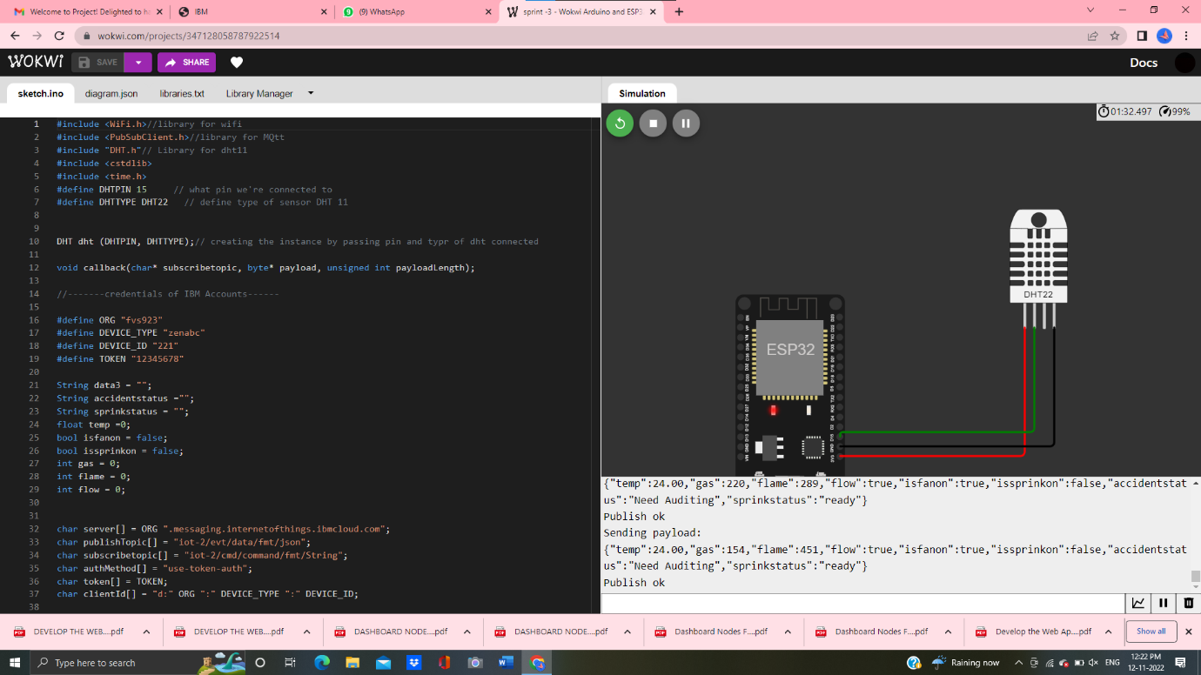

**Physical Components Used**:

* Esp32 Microcontroller
* Dht22 Temperature and Gas Sensor

**Digital Data (Random Data):**

* Flame Sensor
* Flow Sensor